ASSIGNMENT 12.4
NAME: K.Uma Maheshwari
2303a52430
Batch: 44
Task 1: Bubble Sort for Ranking Exam Scores
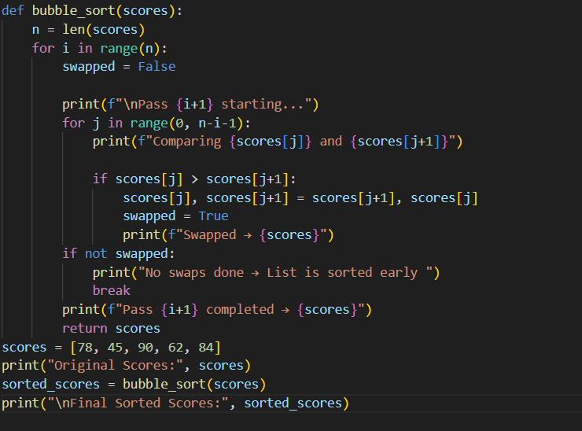
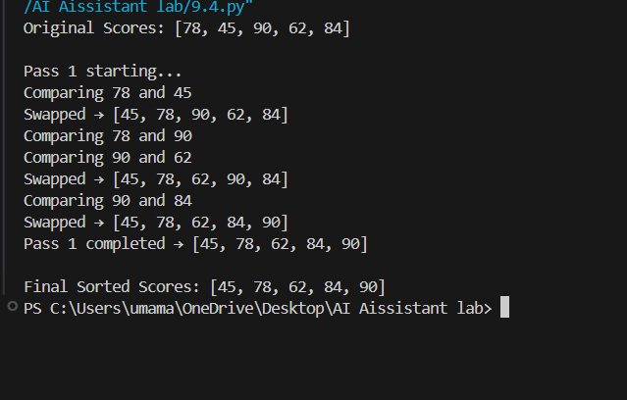
Task 2: Improving Sorting for Nearly Sorted Attendance Records
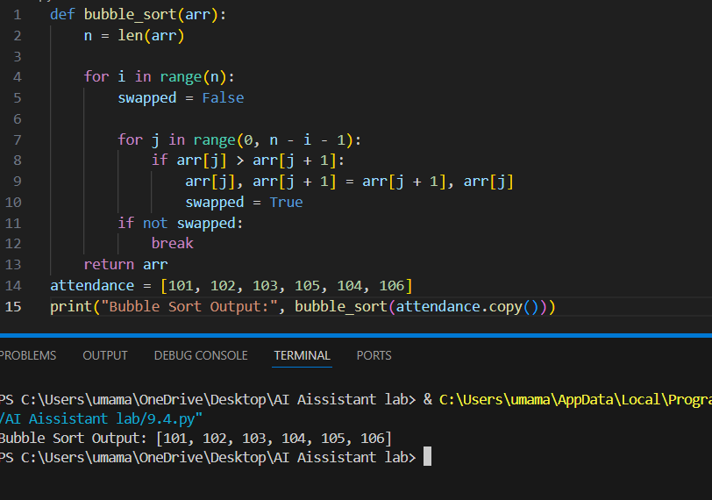
Task 3: Searching Student Records in a Database
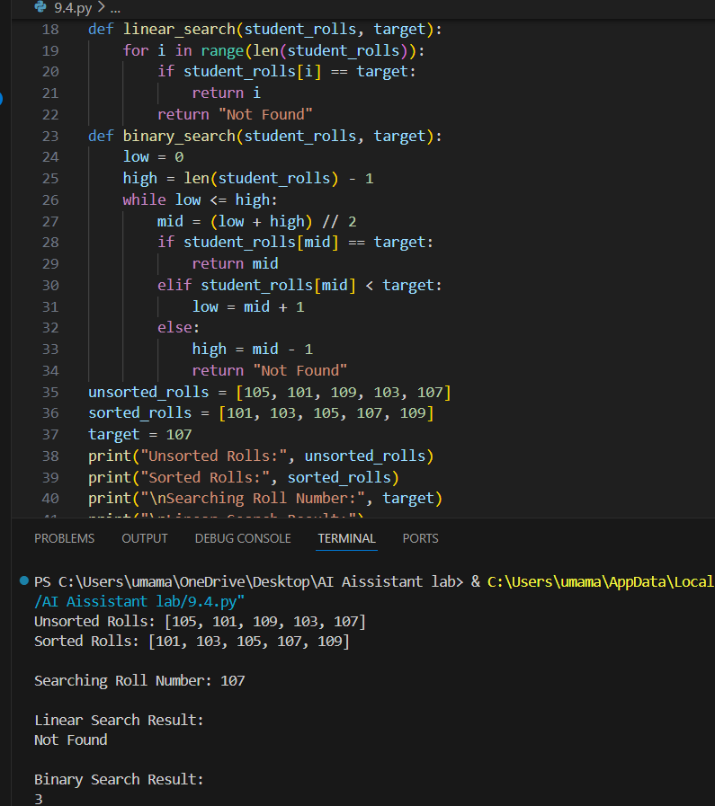
Task 4: Choosing Between Quick Sort and Merge Sort for Data Processing
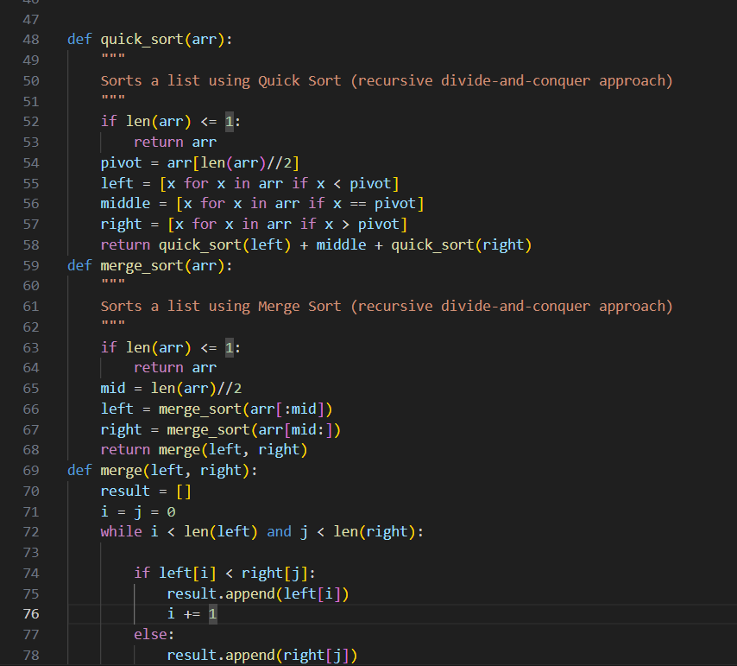
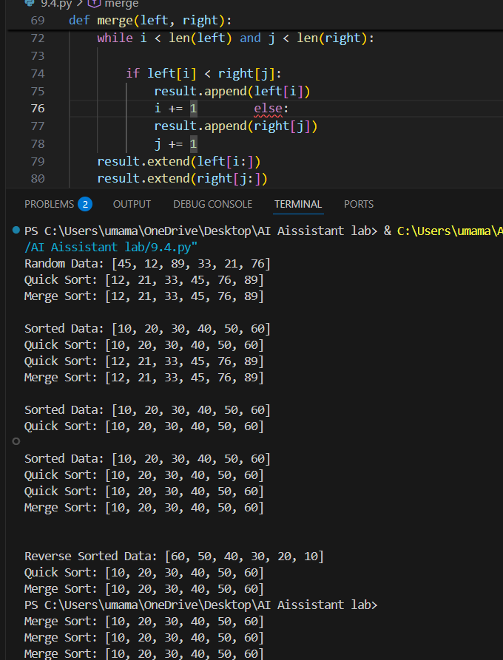

Task 5: Optimizing a Duplicate Detection Algorithm
